Final Project Progress – Part1

Prepared by:
Dinh Khoa Chau
Tuan Duong Huynh
Frances Marie Limlengco
Side Mi
Professor: Pedram Habibi
Course: SOA915

Design and implement the core microservices
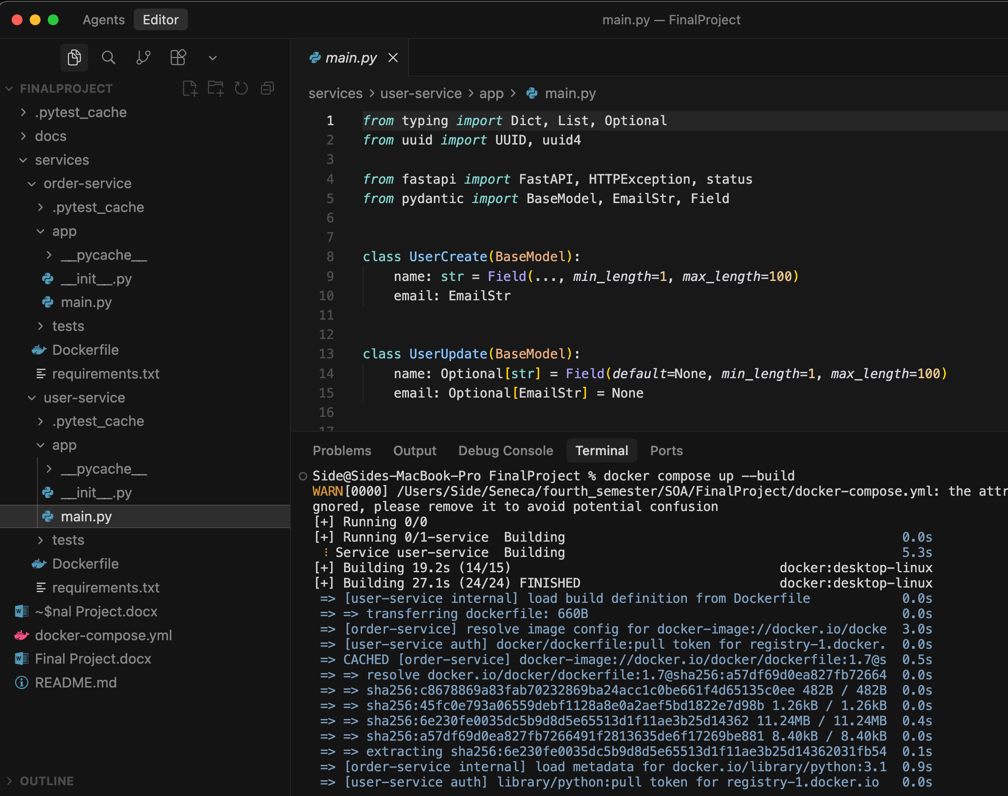
We created two services, one named order-service, another named user-service.
In order-service, we implement 3 RESTful APIs: create order, get orders and get order by id.
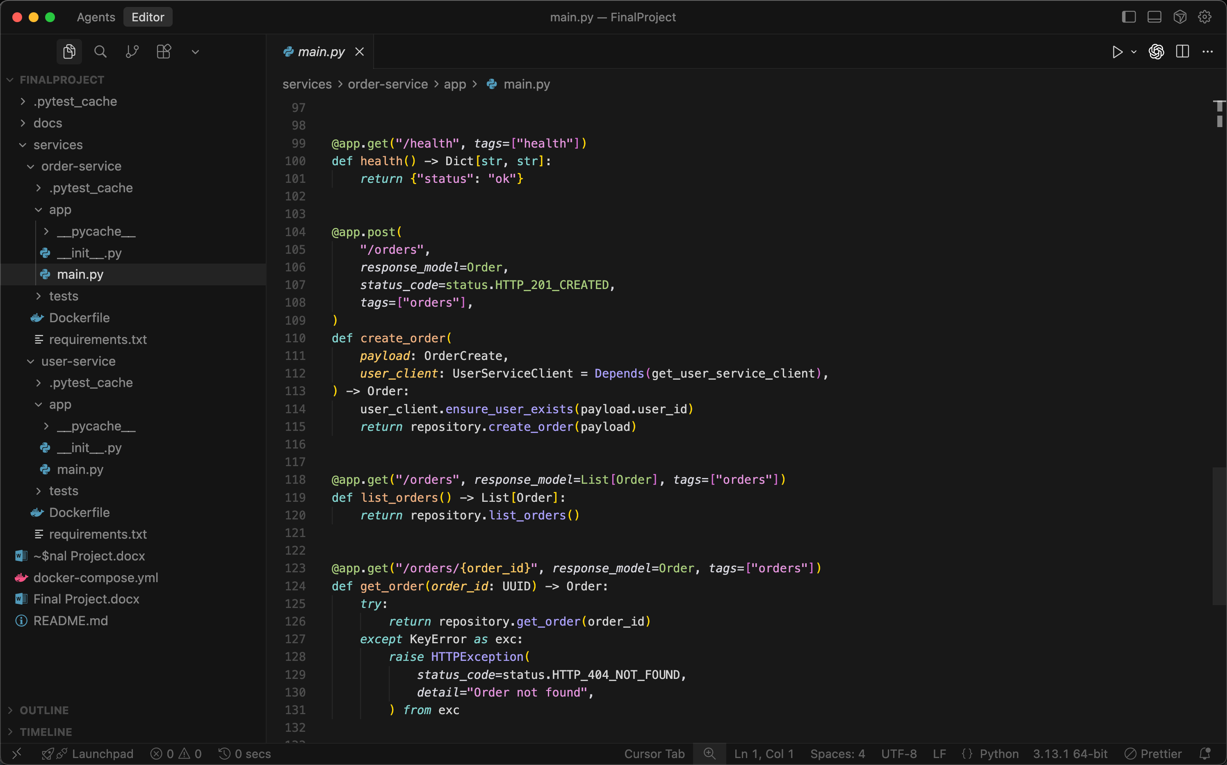

Dockerize the services by creating functional Dockerfiles.
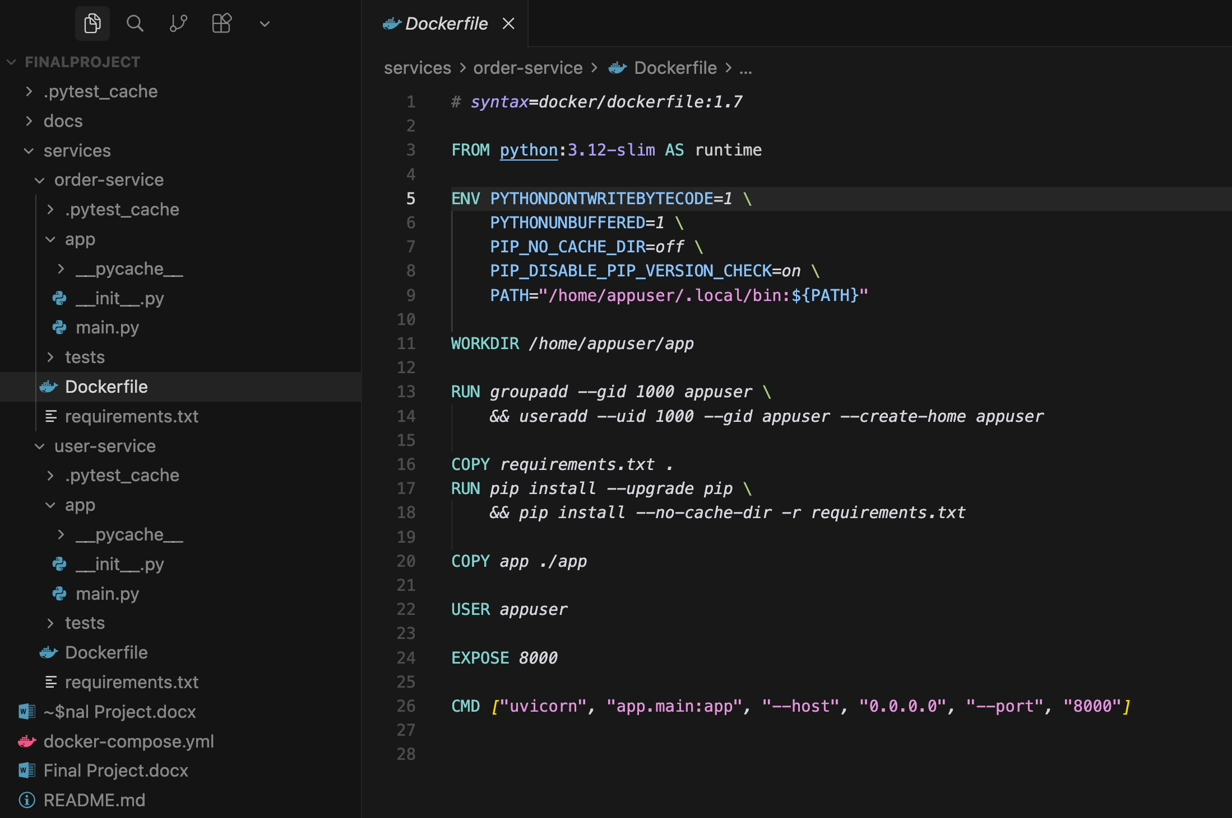
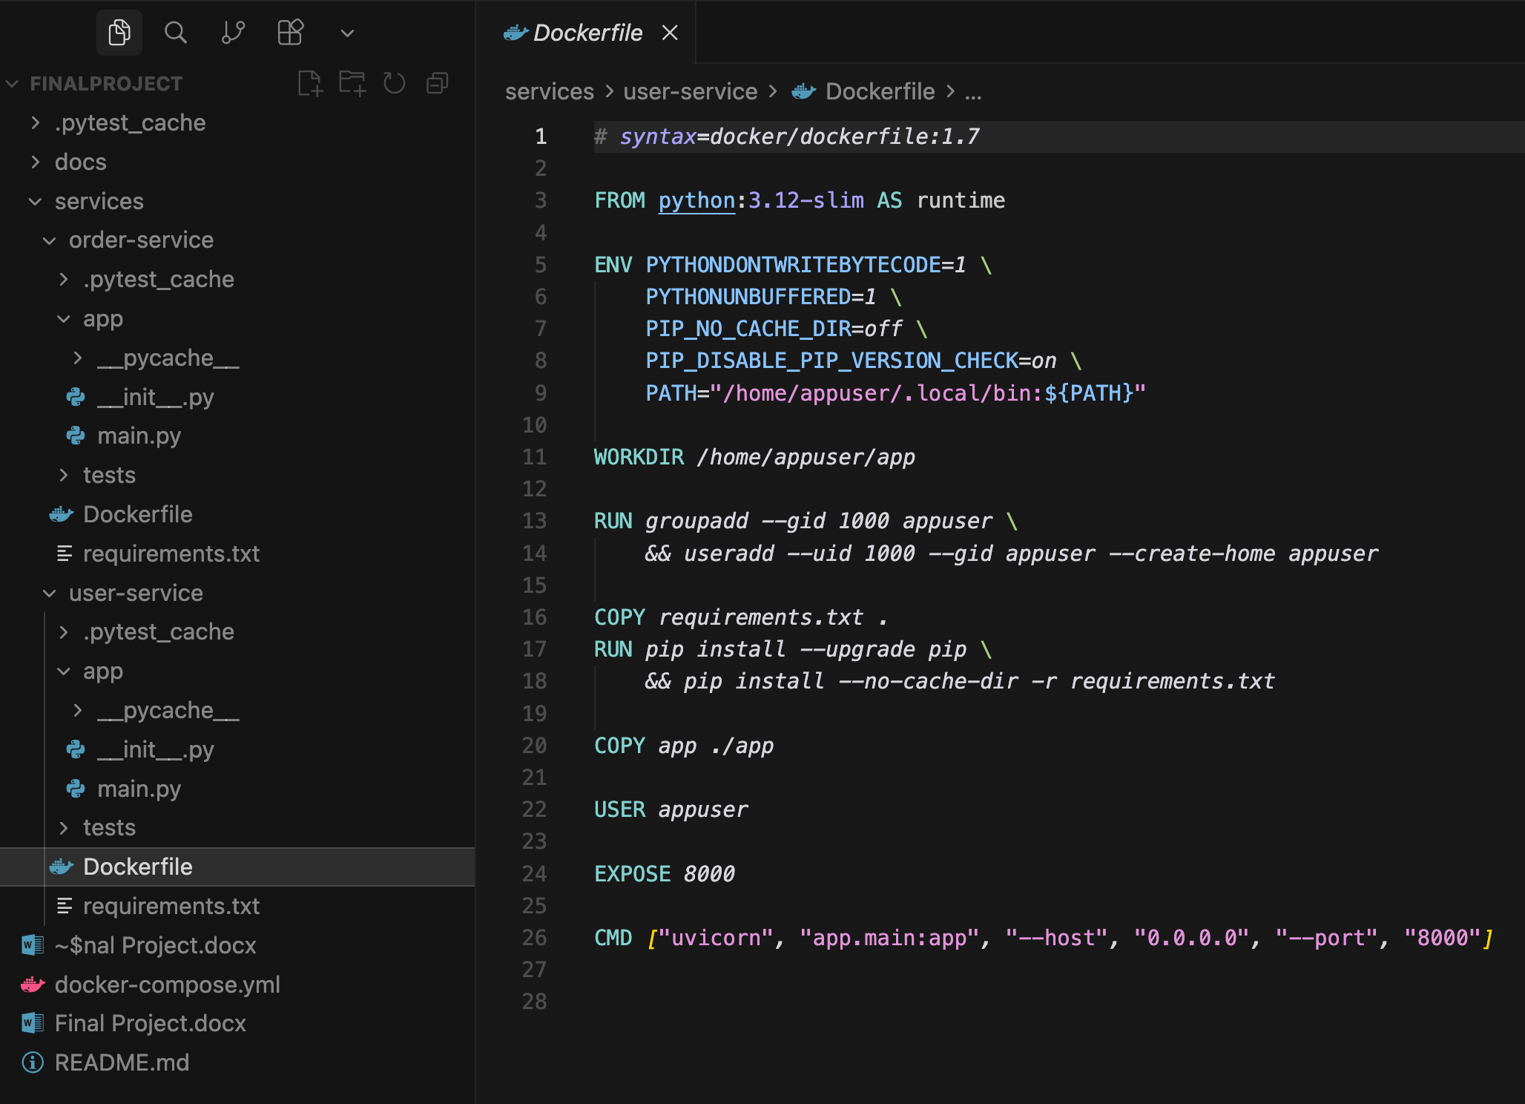
This is the docker file in order and user service.

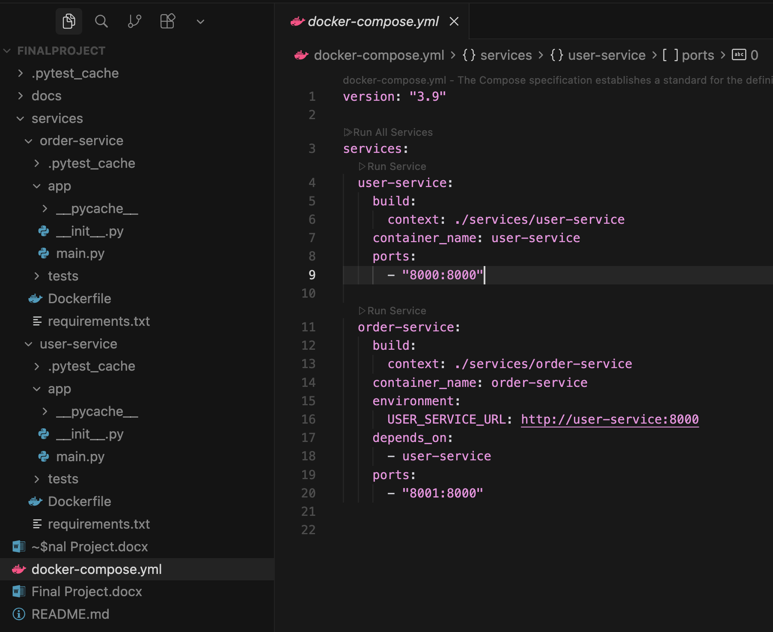
This is docker-compose.yml in the main directory, to deploy all the services to Docker.

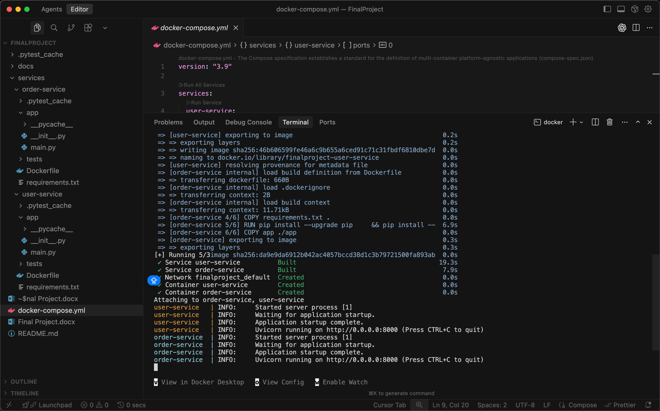
Run command: docker compose up –build, to put docker to local.

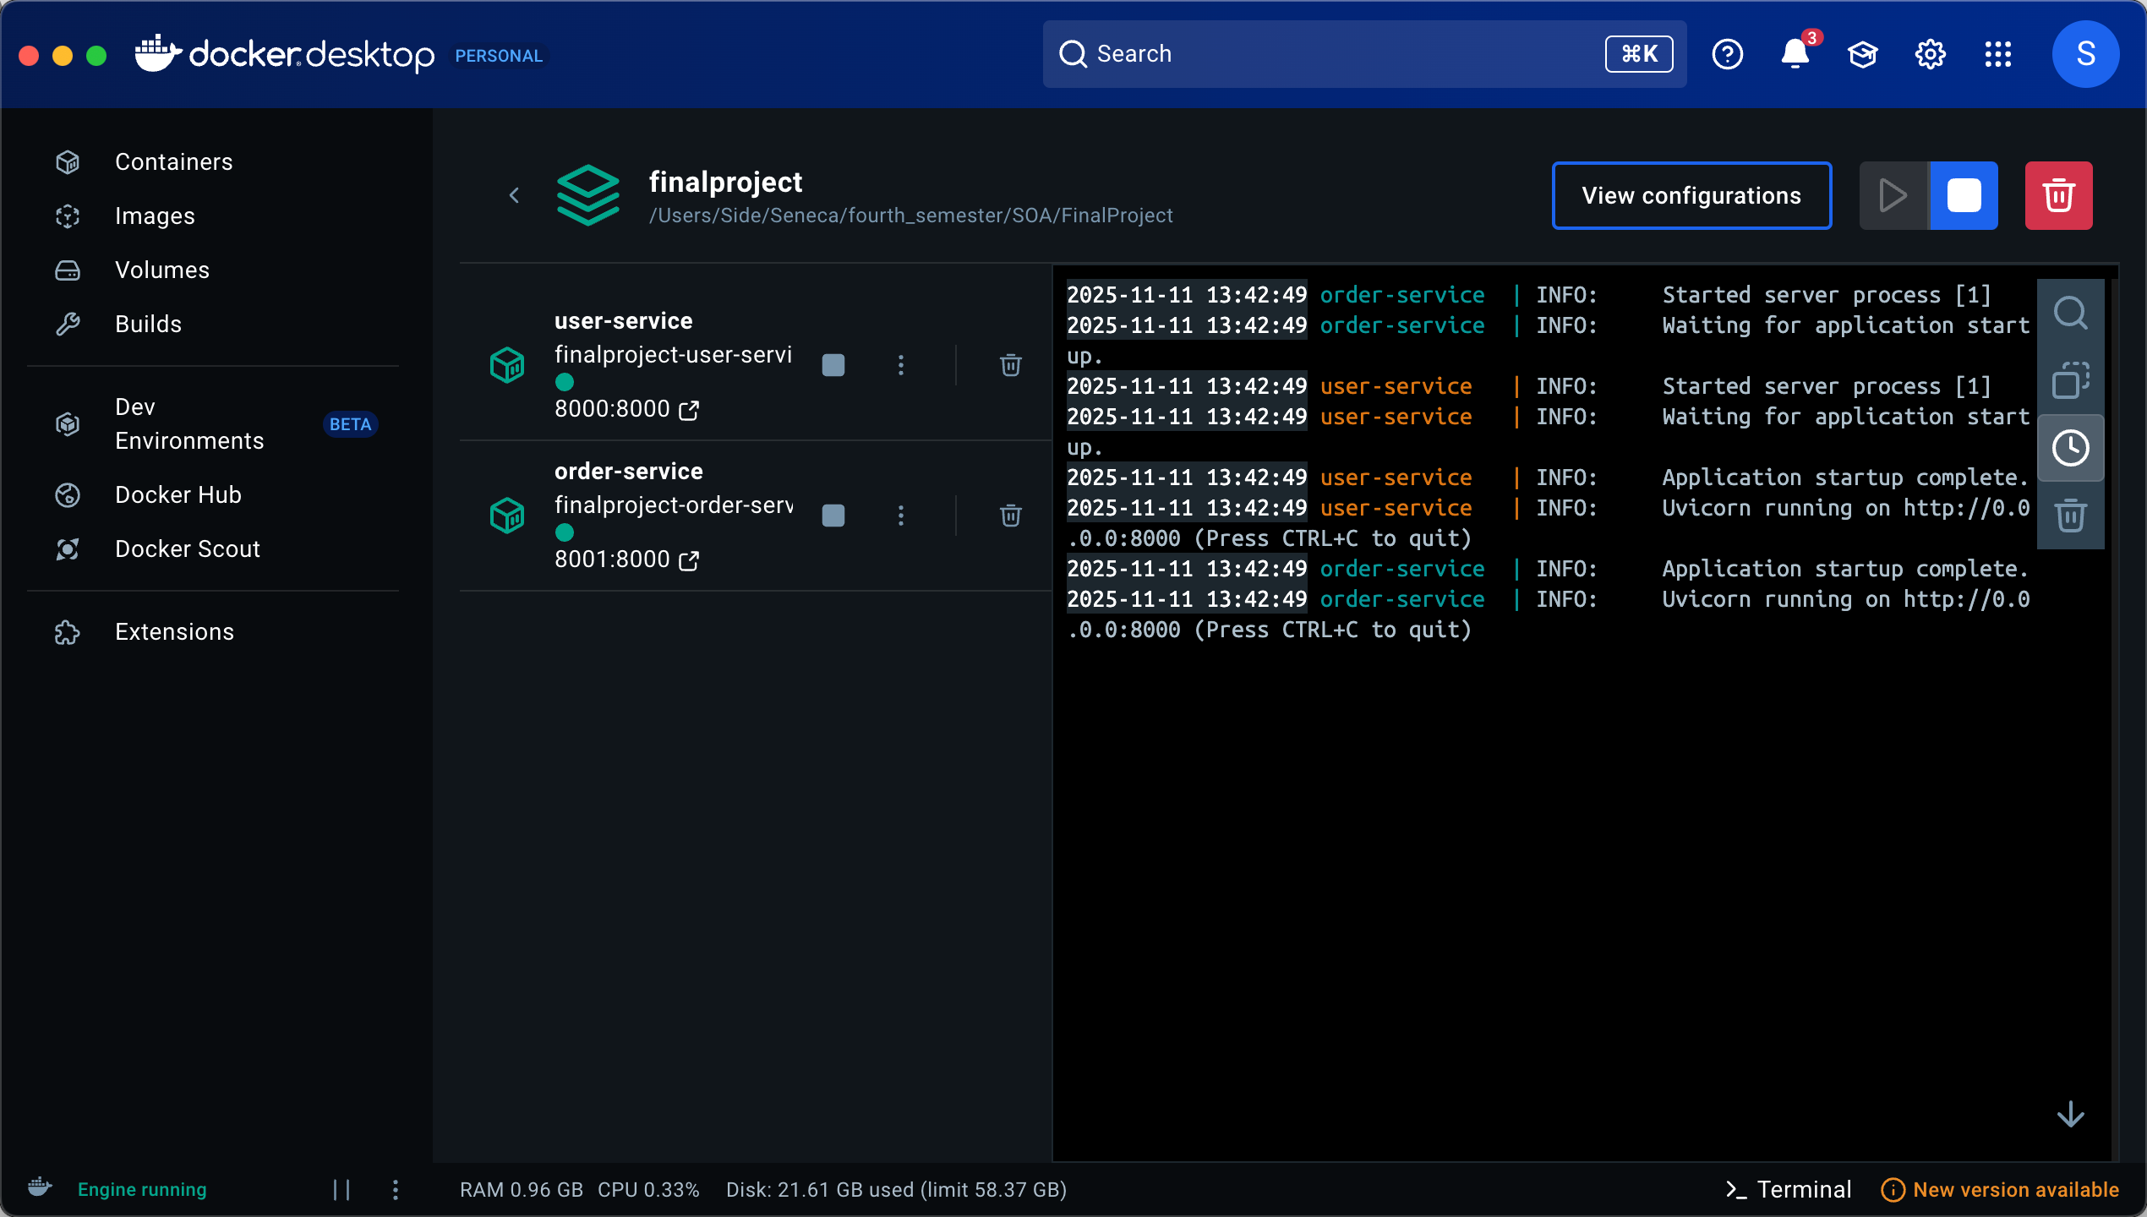
Show local Docker’s services

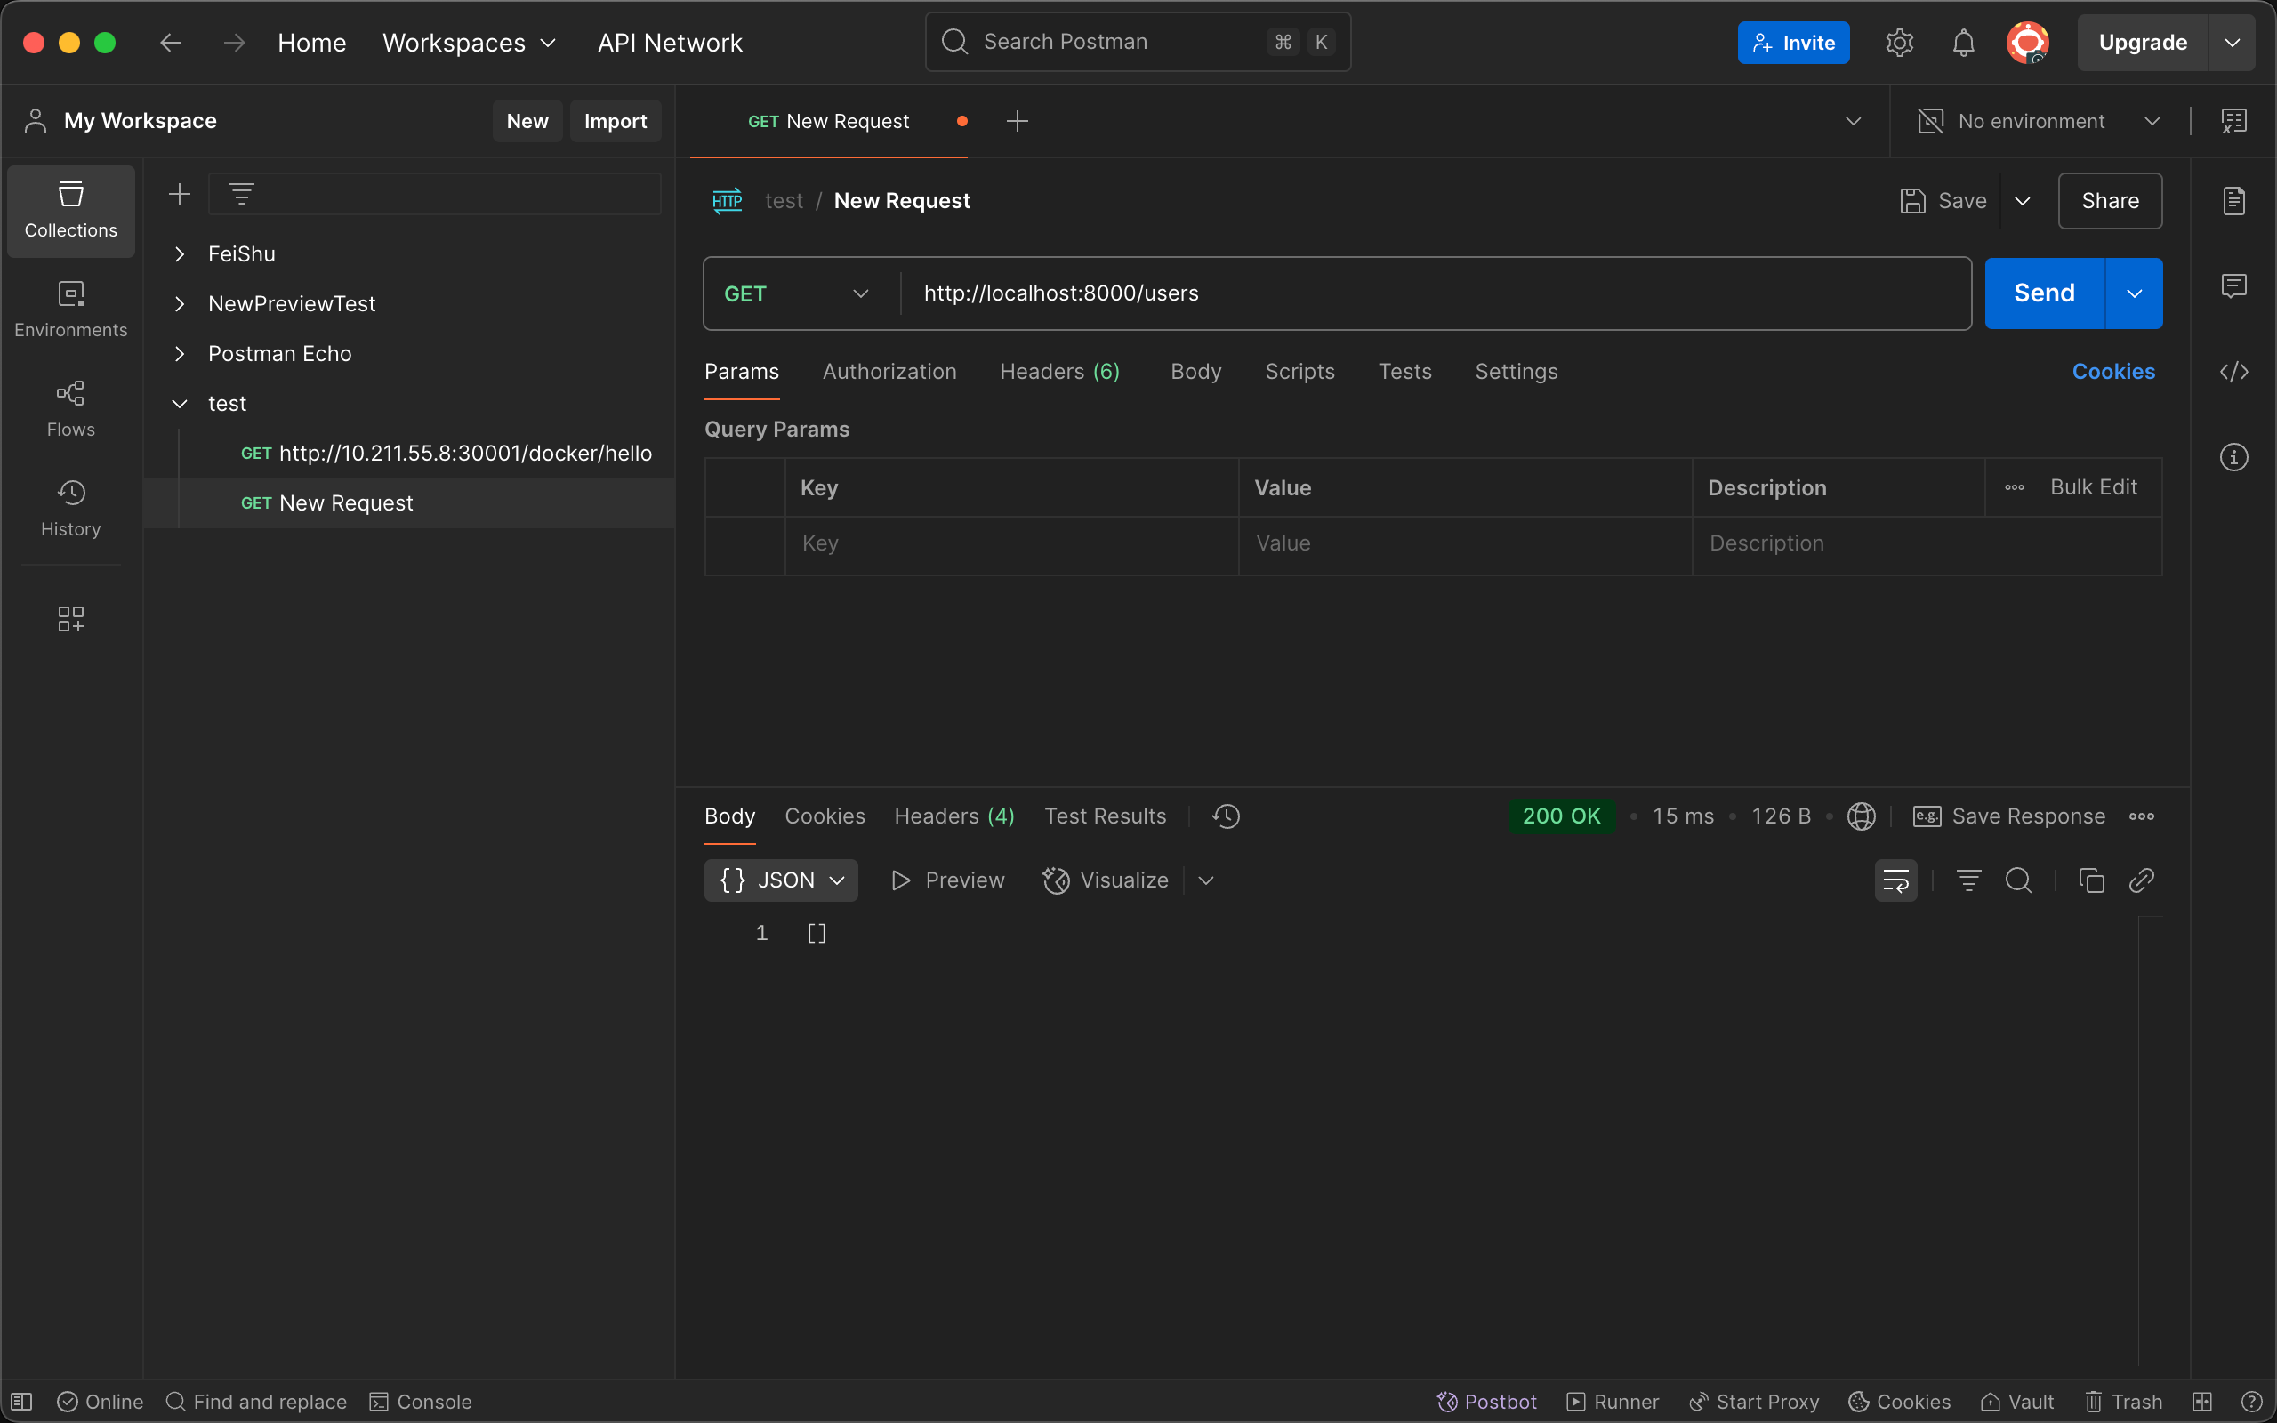
Test user-service api to get all users.
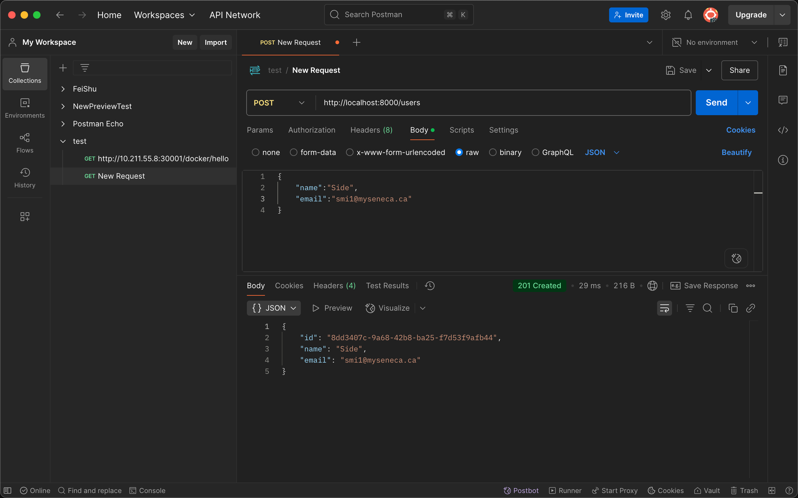
Add user to user-service, and get the id.

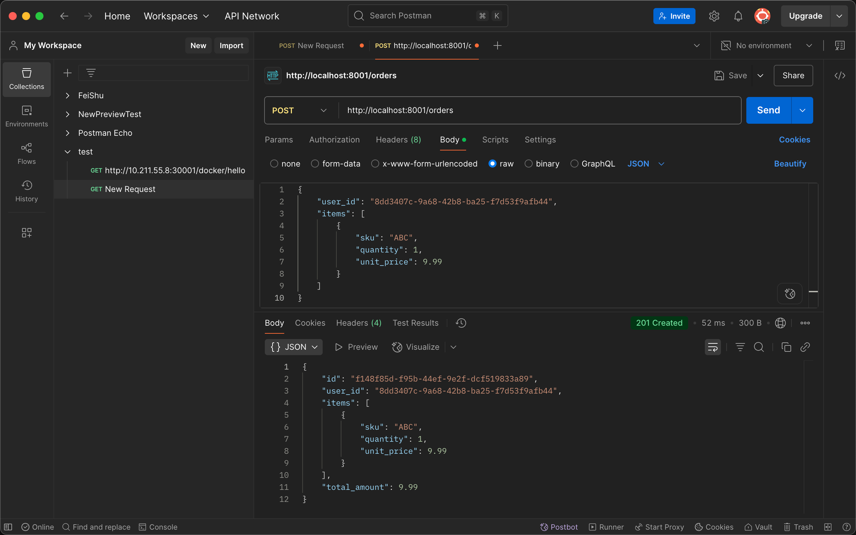
Create order to order-service
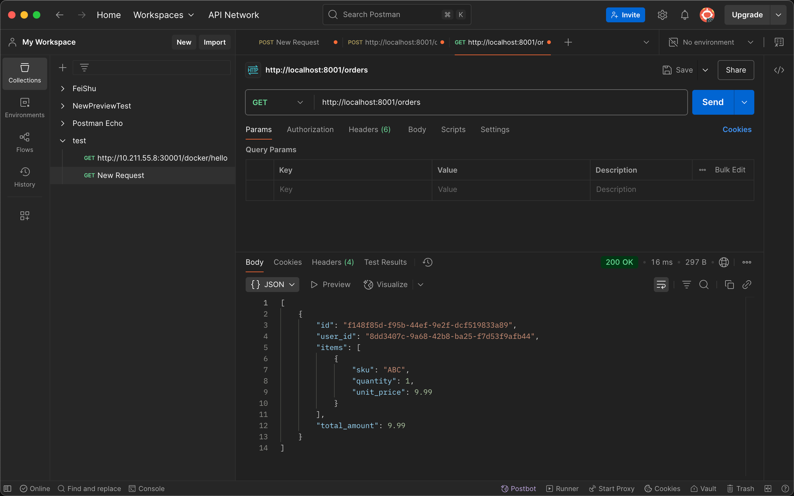
get orders which we created before

